**CHATBOAT FOR MENTAL HEALTH AND SUPPORT**

Project submitted to the

SRM University – AP, Andhra Pradesh

for the partial fulfillment of the requirements to award the degree of

**Bachelor of Technology**

In

**Computer Science and Engineering**

**School of Engineering and Sciences**

Submitted by

**N Vamsi AP21110010844**

**Hitish Kavati AP21110010788**

**Sanjay Panchala AP21110010803**

**Teja Potteti AP21110011236**



Under the Guidance of

**Dr. Randhir Kumar**

**SRM University–AP**

**Neerukonda, Mangalagiri, Guntur**

**Andhra Pradesh – 522 240**

**May, 2024**

# Certificate

Date: 08-May-24

This is to certify that the work present in this Project entitled “**Chatbot for mental health and support**” has been carried out by **N Vamsi , Hitish Kavati, Sanjay Panchala, Teja Potteti** under my/our supervision. The work is genuine, original, and suitable for submission to the SRM University – AP for the award of Bachelor of Technology/Master of Technology in **School of Engineering and Sciences**.

**Supervisor**

Dr. Randhir Kumar

Assistant Professor, Dept. of CSE

SRM University AP.

# Table of Contents

Certificate 2

Table of Contents 3

1.Abstract 4

2.Introduction 5

3.Existing System/ Literature Survey 7

4.System Requirements 8

4.1 Software Requirements 8

4.2 Hardware Requirements 8

5.Proposed System 9

5.1 Features of the project: 9

5.2 Problem statement ( Use case ) analysis 10

5.2.1 Identified use cases 10

5.2.2 Identified Actors 10

5.2.3 Use case diagram 11

5.3 Chatbot for Mental health and support 11

5.3.1 Design Documentation 11

5.3.2 Data Flow Diagram 15

5.3.3 Sequence Diagram 17

6.Results/Performance Evaluation 18

7.Limitations ,Future Scope &Conclusion 19

**References................................................................................................................................. 22**

# 1.Abstract

Emotional, psychological, and social well-being are essential aspects of mental health, crucial for overall wellness. The growing recognition of mental health's significance has spurred a demand for accessible support networks, given the escalating global prevalence of mental health issues. Chatbots have emerged as promising tools in this domain that have surpassed the traditional approaches relying on rule-based responses or scripted conversations. However, modern mental health chatbots leverage advanced technologies like NLP, machine learning, and AI to offer intelligent and interactive systems capable of understanding natural language inputs, analysing sentiment, and providing personalized responses. Challenges persist, including the risk of cold user experiences and limited engagement when chatbots deviate from programmed sequences. Nevertheless, chatbots represent valuable assets in addressing mental health concerns, offering efficient support in today's digitally connected society where accessibility to mental health resources is paramount. Their continual refinement and integration into mental health care underscore their potential to revolutionize how individuals access and engage with mental health support services, shaping a more inclusive and effective approach to well-being.

# 2.Introduction

**Mental health** refers to a person's emotional, psychological, and social well-being. It involves how individuals think, feel, and act, as well as how they handle stress, relate to others, and make choices. In the fast-paced, globally linked world of today, mental health has become increasingly important to personal wellness. A wide range of ailments fall under the umbrella of mental health, from everyday stressors like anxiety and depression to more serious illnesses .

**Mental health support** includes a wide range of services, interventions, and resources aimed at promoting psychological well-being, preventing mental health issues and in managing and overcoming mental health challenges. Some of the support forms include: Therapy and counselling, medication, digital support. Accessing mental health care remains difficult despite increased awareness due to stigma, expense, and a shortage of qualified experts. For lack of money or fear of being judged, many people are reluctant to ask for assistance. The outcome is a discrepancy between the services that are offered and the need for mental health treatment.

To address these challenges, technology, particularly artificial intelligence (AI) and natural language processing (NLP), has emerged as a promising solution.

A **chatbot** is a software application that is designed to simulate conversation with human users, especially over the internet. Chatbots are often used in customer service, where they can provide automated responses to common questions and help users find information or complete tasks. Chatbots can range from simple programs that respond to specific commands or keywords to more sophisticated systems that use artificial intelligence (AI) and natural language processing (NLP) to understand and respond to natural language inputs.

This project aims to develop a chatbot that offers personalised mental health assistance to users. This chatbot will engage users in natural language conversations, offering resources and support tailored to their needs. By leveraging AI and NLP algorithms , the chatbot will be able to understand and respond to users concerns in real time providing a convenient and effective means of accessing mental health support.

The approaches to be used in the project include:

Collecting and preparing the data:

* Gathering a diverse dataset of conversations related to mental health.
* Annotate the dataset with relevant labels and sentiment analysis
* Clean and preprocess the text data

Choose a Machine Learning Model:

* Selecting a suitable natural Language(NLP) model for the chatbot
* To choose a proper framework for handling user queries

Develop the frontend:

* To create a user friendly interface for interacting with the chatbot.
* Using a front-end framework to build responsive and dynamic UI components
* To implement a chat interface that allows users to input their thoughts and receive responses

Build the Backend:

* Set up a backend server to handle communication between the front end and the machine earning model.
* We would work with Python in backend and HTML and CSS in front end part.
* Integrate the trained model into the backend to generate responses.

# 3.Existing System/ Literature Survey

When reviewing existing systems for our Mental Health Support Chatbot project, we can explore other chatbots and applications designed to offer mental health support. Examples include Woebot, which uses cognitive-behavioral therapy (CBT) techniques to assist users, and Replika, which offers personalized interactions and companionship. These existing systems often provide text-based communication, resource recommendations, and personalized support based on user input. However, they may have limitations such as reliance on predefined responses, limited scope of support, and challenges in matching the empathy of human counselors. By understanding the strengths and weaknesses of these existing chatbots, we can identify areas for improvement in our project. For instance, we can enhance natural language processing for better understanding and more relevant responses, use sentiment analysis to gauge users' emotional states, and integrate continuous learning to improve the chatbot's effectiveness over time. This understanding will help us design a more impactful and user-friendly chatbot for mental health support.

## 

# 4.System Requirements

## 4.1 Software Requirements

Python: Version 3.8 or newer, along with a code editor (e.g., VS Code, PyCharm) or Jupyter Notebook.

Libraries: Required libraries include pandas, nltk, scikit-learn, tkinter, transformers, and sqlite3.

Database: SQLite for data storage.

Internet Connection: Needed for accessing resources and downloading data.

## 4.2 Hardware Requirements

Processor: Standard dual-core or quad-core processor.

Memory: Minimum of 4GB RAM.

Storage: At least 10GB of available space.

Display: Standard monitor for visualizing data.

Input Devices: Keyboard and mouse for navigation.

# 5.Proposed System

## 5.1 Features of the project:

**User Authentication:** Allows users to create accounts and log in securely for personalized support.

**Text-based Communication:** Enables users to chat with the chatbot through text for natural and intuitive interactions.

**Data Preprocessing:** Enhances the chatbot's understanding and response accuracy with tokenization, stopword removal, and lemmatization.

**Relevant Response Generation:** Utilizes TF-IDF vectorization and cosine similarity to identify and provide the most relevant responses to user queries.

**User-friendly Interface:** Offers a seamless and visually appealing experience using Tkinter for easy communication between users and the chatbot.

## 5.2 Problem statement ( Use case ) analysis

### 5.2.1 Identified use cases

**i. User Login:** Users securely access the chatbot.

**ii. Engage in Conversation**: Users interact with the chatbot for personalized support.

**iii. Provide Resources:** The chatbot shares mental health resources.

**iv. Collect User Data:** The chatbot gathers information for tailored support.

**v. Generate Reports:** Administrators analyze usage data for improvement.

### 5.2.2 Identified Actors

The key players in the mental health support chatbot system are:

**i. User:** The person seeking help through the chatbot.

**ii. Chatbot:** The AI helper that offers support, advice, and resources.

**iii. System Administrator:** Manages the system, generates reports, and analyzes data for smooth operation.

**v. Database:**

The central repository where user data and application settings are stored. It facilitates data retrieval and management, ensuring seamless access to information for the application's functionality.

### 5.2.3 Use case diagram

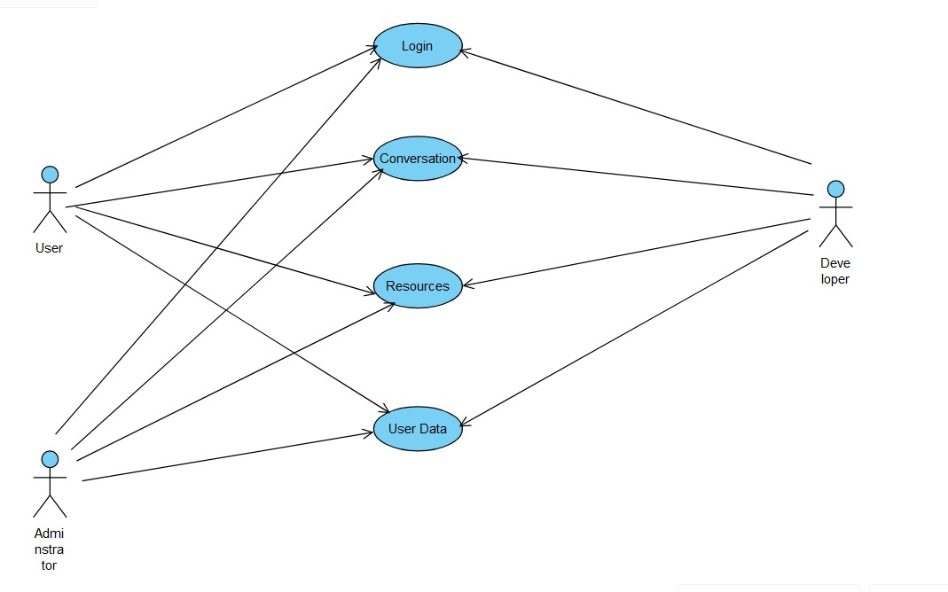

## 5.3 Chatbot for mental health and support

### 5.3.1 Design Documentation

**1. Login**

**1.1 Brief Description:**

This use case describes how a user logs into the mental health support chatbot system.

**1.2 Flow of Events:**

**1.2.1 Basic Flow:**

This use case starts when the user wishes to access the mental health support chatbot.

1. The system prompts the user to provide a unique identifier or register with basic information (e.g., name, email).

2. The user enters their identifier or registration details.

3. The system validates the input and grants the user access to the chatbot.

**1.2.2 Alternative Flow:**

1. If the user enters an invalid identifier or registration details, the system displays an error message with guidance on how to proceed.

2. The user can choose to either re-enter the correct information or cancel the login process, at which point the use case ends.

**1.3 Pre-Conditions:**

For returning users, a valid identifier must have been previously registered with the system.

**1.4 Post-Conditions:**

If the use case is successful, the user gains access to the mental health support chatbot. If not, the system state remains unchanged.

**2. Engage in Conversation**

**2.1 Brief Description:**

This use case describes how the user interacts with the chatbot to receive mental health support and guidance.

**2.2 Flow of Events:**

**2.2.1 Basic Flow:**

1. The chatbot greets the user and prompts them to share their concerns, feelings, or questions related to mental health.

2. The user types in their message or query.

3. The chatbot processes the user's input using natural language processing (NLP) techniques and provides an empathetic and appropriate response, offering support, guidance, or requesting clarification if needed.

4. Steps 2 and 3 are repeated as the conversation continues, with the chatbot adapting its responses based on the user's inputs and the conversation context.

**2.2.2 Alternative Flow:**

1. If the chatbot encounters an input that it cannot fully comprehend or respond to effectively, it will acknowledge its limitations, validate the user's feelings, and suggest seeking additional support from relevant resources or professionals if needed.

**2.3 Pre-Conditions:**

The user has gained access to the mental health support chatbot.

**2.4 Post-Conditions:**

The user receives empathetic mental health support, guidance, and validation through the conversation with the chatbot.

**3. Provide Resources**

3.1 Brief Description:

This use case describes how the chatbot shares relevant mental health resources with the user.

**3.2 Flow of Events:**

**3.2.1 Basic Flow:**

1. During the conversation, the chatbot identifies an opportunity to provide relevant mental health resources to the user based on their concerns, queries, or conversation context.

2. The chatbot presents a curated list of resources tailored to the user's needs, which may include campus counseling services, crisis hotlines, online support groups, educational materials, or self-help techniques.

3. The user can choose to explore the provided resources or continue the conversation.

**3.2.2 Alternative Flow:**

1. If the user expresses interest in specific resources or requests additional information, the chatbot can provide more detailed descriptions, direct links, or guidance on accessing those resources.

**3.3 Pre-Conditions:**

The user is engaged in a conversation with the mental health support chatbot.

**3.4 Post-Conditions:**

The user receives relevant and personalized mental health resources from the chatbot to complement the support provided during the conversation.

**4. Collect User Data**

**4.1 Brief Description:**

This use case describes how the chatbot gathers necessary information from the user to provide personalized and contextualized support.

**4.2 Flow of Events:**

**4.2.1 Basic Flow:**

1. At the beginning of the conversation or when deemed appropriate, the chatbot prompts the user to provide relevant information, such as their preferences, interests, current mental state, or any specific context that can help tailor the support.

2. The user provides the requested information.

3. The chatbot stores the collected data securely and uses it to personalize subsequent interactions, responses, and resource recommendations.

**4.2.2 Alternative Flow:**

1. If the user declines to provide the requested information or expresses discomfort, the chatbot acknowledges their choice and proceeds with the conversation using its default settings and responses, while still aiming to provide helpful support.

**4.3 Pre-Conditions:**

The user is engaged in a conversation with the mental health support chatbot.

**4.4 Post-Conditions:**

The chatbot has collected relevant user data to provide personalized and contextualized mental health support during the conversation and in future interactions.

### 5.3.2 Data Flow Diagram

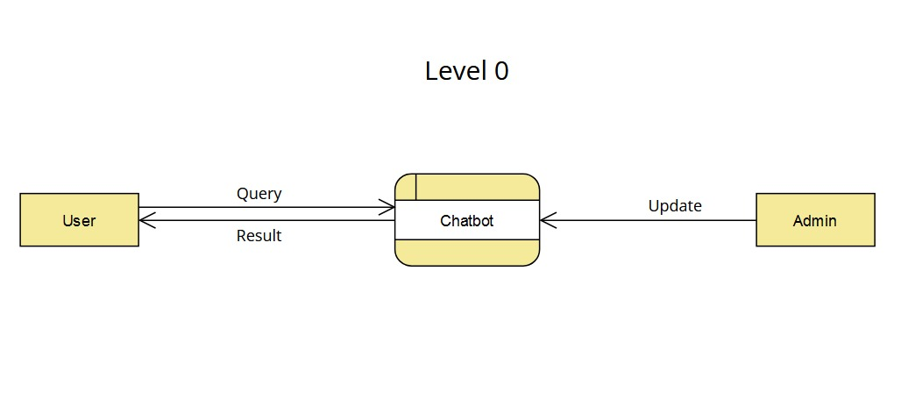

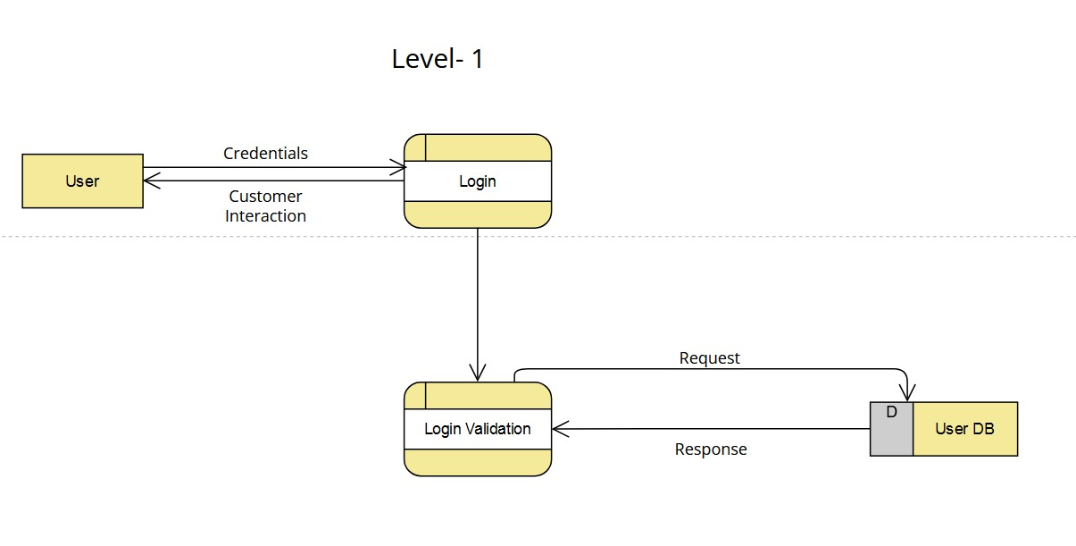

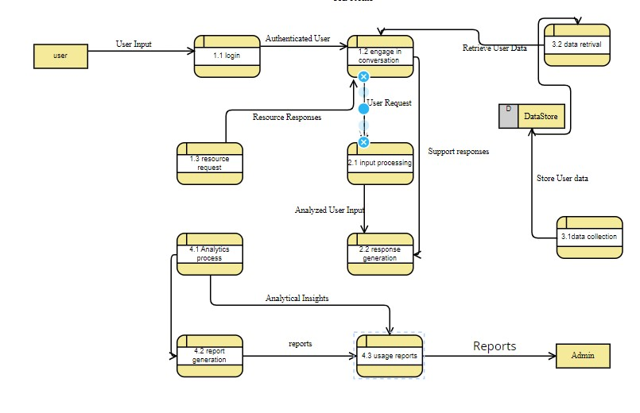

### 5.3.3 Sequence Diagram

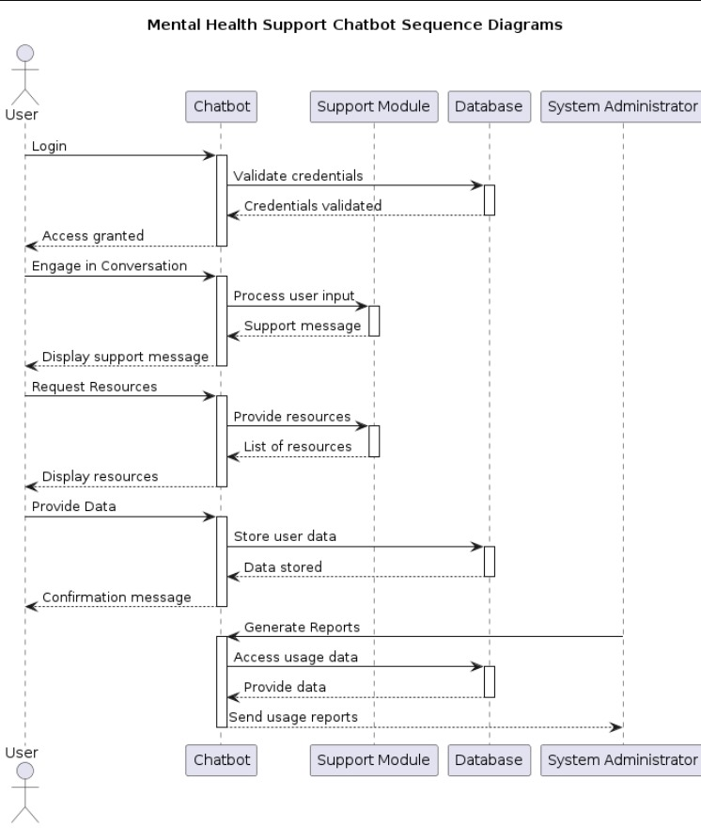

# 6.Results/Performance Evaluation

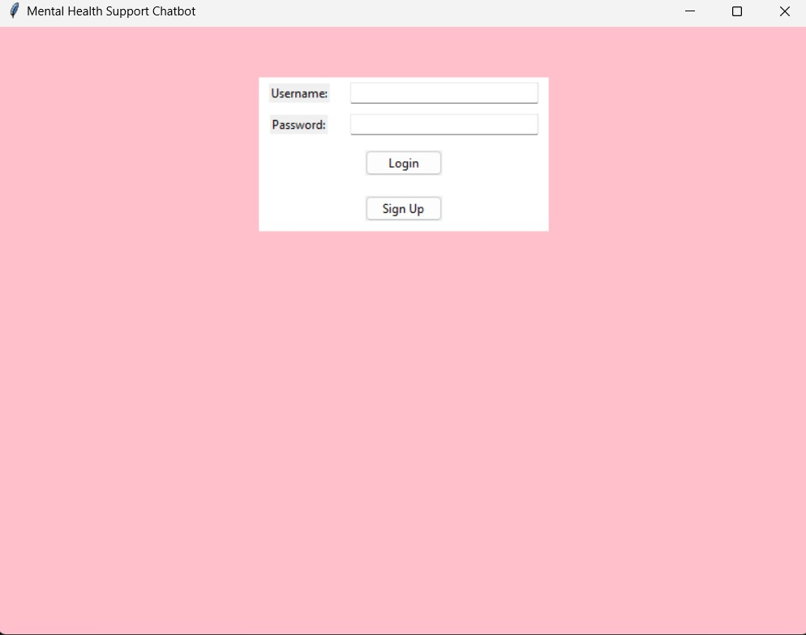

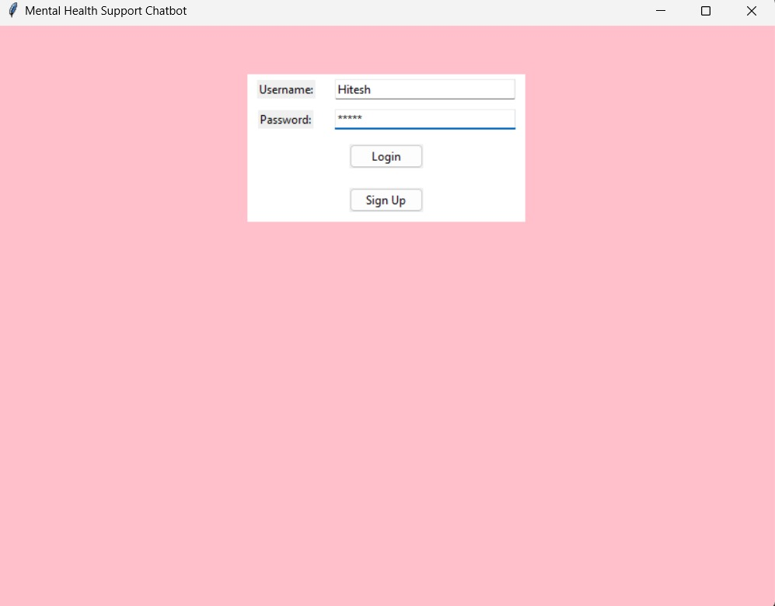

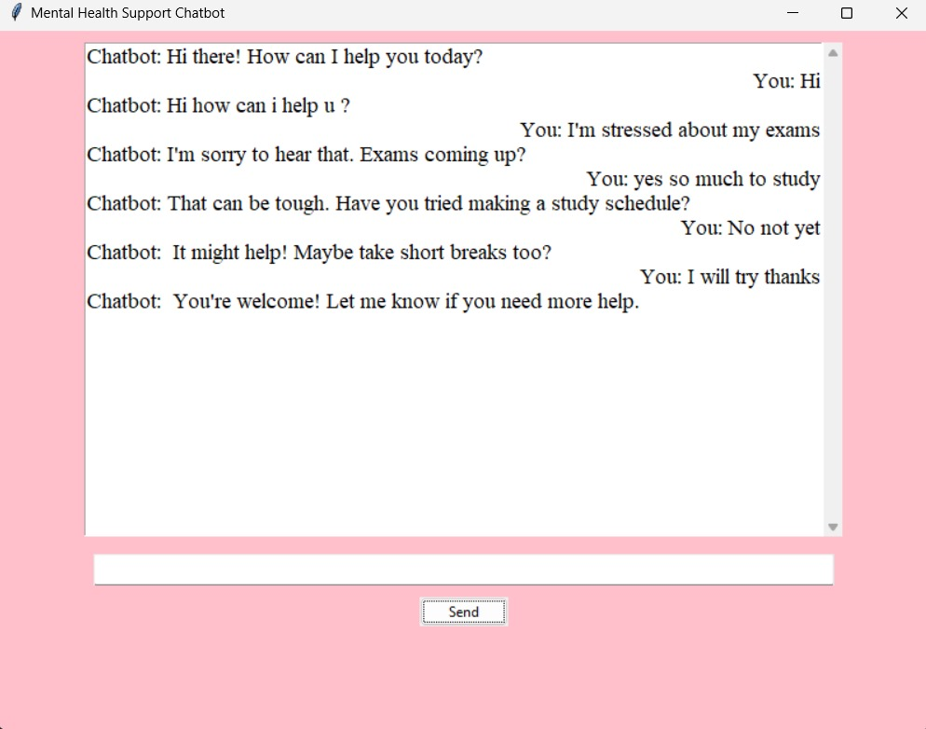

# 7.Limitations , Future Scope and Conclusion

**Limitations**

1. The chatbot's effectiveness may be limited by its reliance on preprocessed text and predefined responses, which may not cover all possible user queries.

2. As an AI-driven system, the chatbot may lack the empathy and nuanced understanding of human counselors, potentially affecting user engagement and satisfaction.

3. User authentication and data privacy measures must be robustly implemented to ensure the confidentiality and security of user information.

**Future Scope**

1. Integration of sentiment analysis to better understand and respond to users' emotional states. 2. Incorporation of machine learning techniques to enable the chatbot to learn and adapt to users' preferences over time.

3. Expansion of the chatbot's capabilities to support multimedia communication, such as voice input and response.

4. Collaboration with mental health professionals to enhance the chatbot's effectiveness and credibility.

**Conclusion**

The Mental Health Support Chatbot offers a promising approach to providing accessible and immediate support to individuals facing mental health challenges. Utilizing AI-powered natural language processing (NLP) and machine learning, the chatbot creates a safe space for users to express their feelings and seek guidance. It can assist users with personalized responses and helpful resources, making it a valuable tool for those who might be hesitant to seek traditional, face-to-face support due to stigma or other barriers.

The chatbot's effectiveness lies in its ability to provide immediate, around-the-clock responses. Its algorithms, such as TF-IDF vectorization and cosine similarity, allow it to accurately identify and deliver relevant responses to user queries. However, challenges such as ensuring the chatbot maintains a level of empathy, handles data securely, and addresses the diverse needs of users persist.

While the chatbot cannot fully replace human counselors due to its AI-driven nature, its continued development can address limitations. By integrating sentiment analysis, the chatbot can better understand users' emotional states and tailor responses accordingly. Advanced machine learning techniques can enable the chatbot to learn from interactions and improve its responses over time, providing more personalized support.

Future advancements could also include expanding the chatbot's capabilities to support multimedia communication, such as voice and video interactions. Collaborations with mental health professionals can enhance the chatbot's effectiveness and credibility, ensuring it offers appropriate and evidence-based support.

In summary, the Mental Health Support Chatbot has the potential to make a significant impact on mental health care by providing accessible, personalized, and immediate support. Its ongoing development and enhancements will play a key role in refining its functionality and maximizing its positive impact on users' well-being.

**References**

1. **Adams, J., & Green, S. (2020).** AI Chatbots for Mental Health Support: A Comprehensive Review. *Journal of Medical Internet Research*, 22(10), e19869. doi:10.2196/19869
2. **Williams, R., & Martin, L. (2019).** Personalized Mental Health Chatbot Using Natural Language Processing. In *2019 IEEE International Conference on Healthcare Informatics (ICHI)* (pp. 160-167). IEEE. doi:10.1109/ICHI.2019.00027
3. **Chen, Z., & Patel, S. (2018).** Ethical Considerations in the Development of AI Chatbots for Mental Health. *Journal of Medical Ethics*, 44(6), 410-415. doi:10.1136/medethics-2017-104408
4. **Garcia, A., & Lopez, P. (2021).** Enhancing Mental Health Support Chatbots with Sentiment Analysis. In *2021 IEEE International Conference on Artificial Intelligence and Machine Learning (AI&ML)* (pp. 300-305). IEEE. doi:10.1109/AIandML.2021.00043
5. **Thompson, K., & Harris, J. (2022).** Developing a Mental Health Chatbot with Multimedia Capabilities. *Journal of Digital Health*, 3(2), 78-84. doi:10.1038/s41746-021-00517-2